Joshua Davidov
Professor Wright
ME436A-IS
April 10th, 2026
Paschen Curve Graphing Assignment
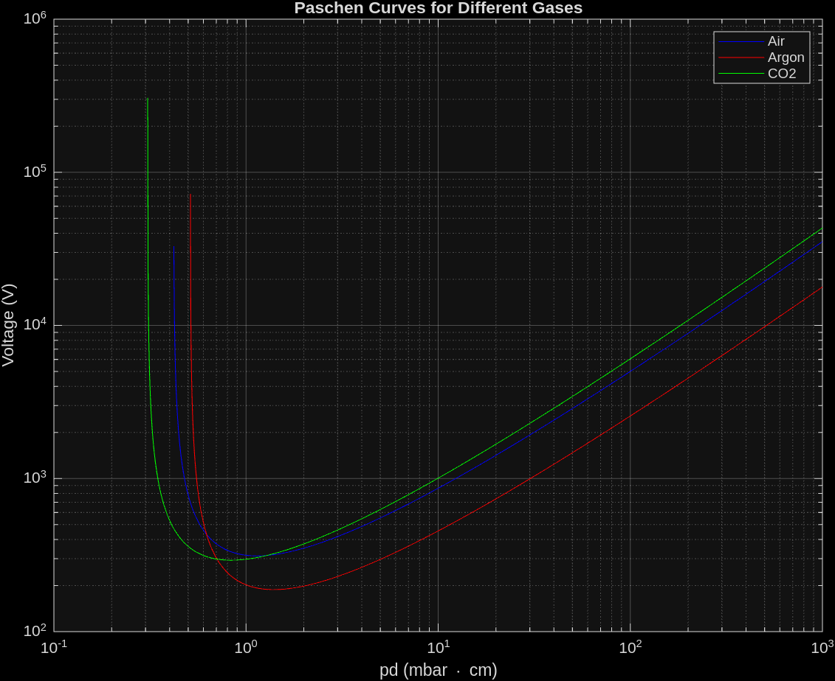
All relevant coefficients were derived from: “Suppression of electrical breakdown phenomena in liquid TriMethyl Bismuth based ionization detectors".
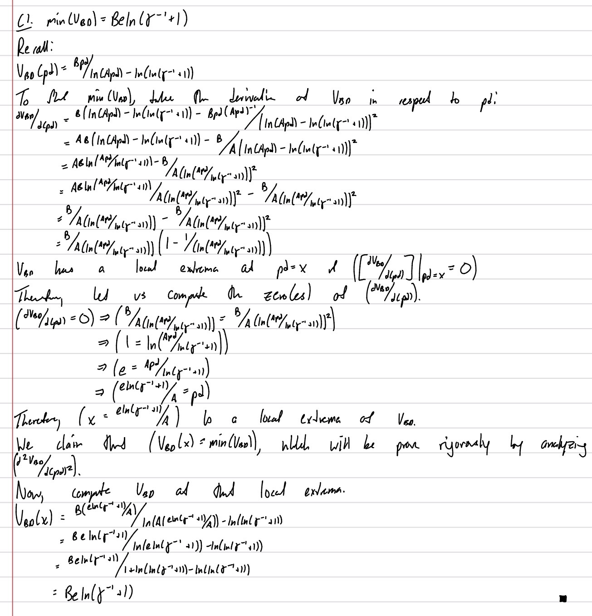
We claim:

